**Co-ordinates**

Table of Contents

Axes Systems 2

Dividing Co-ordinates 3

Finding Determinant 4

## Axes Systems

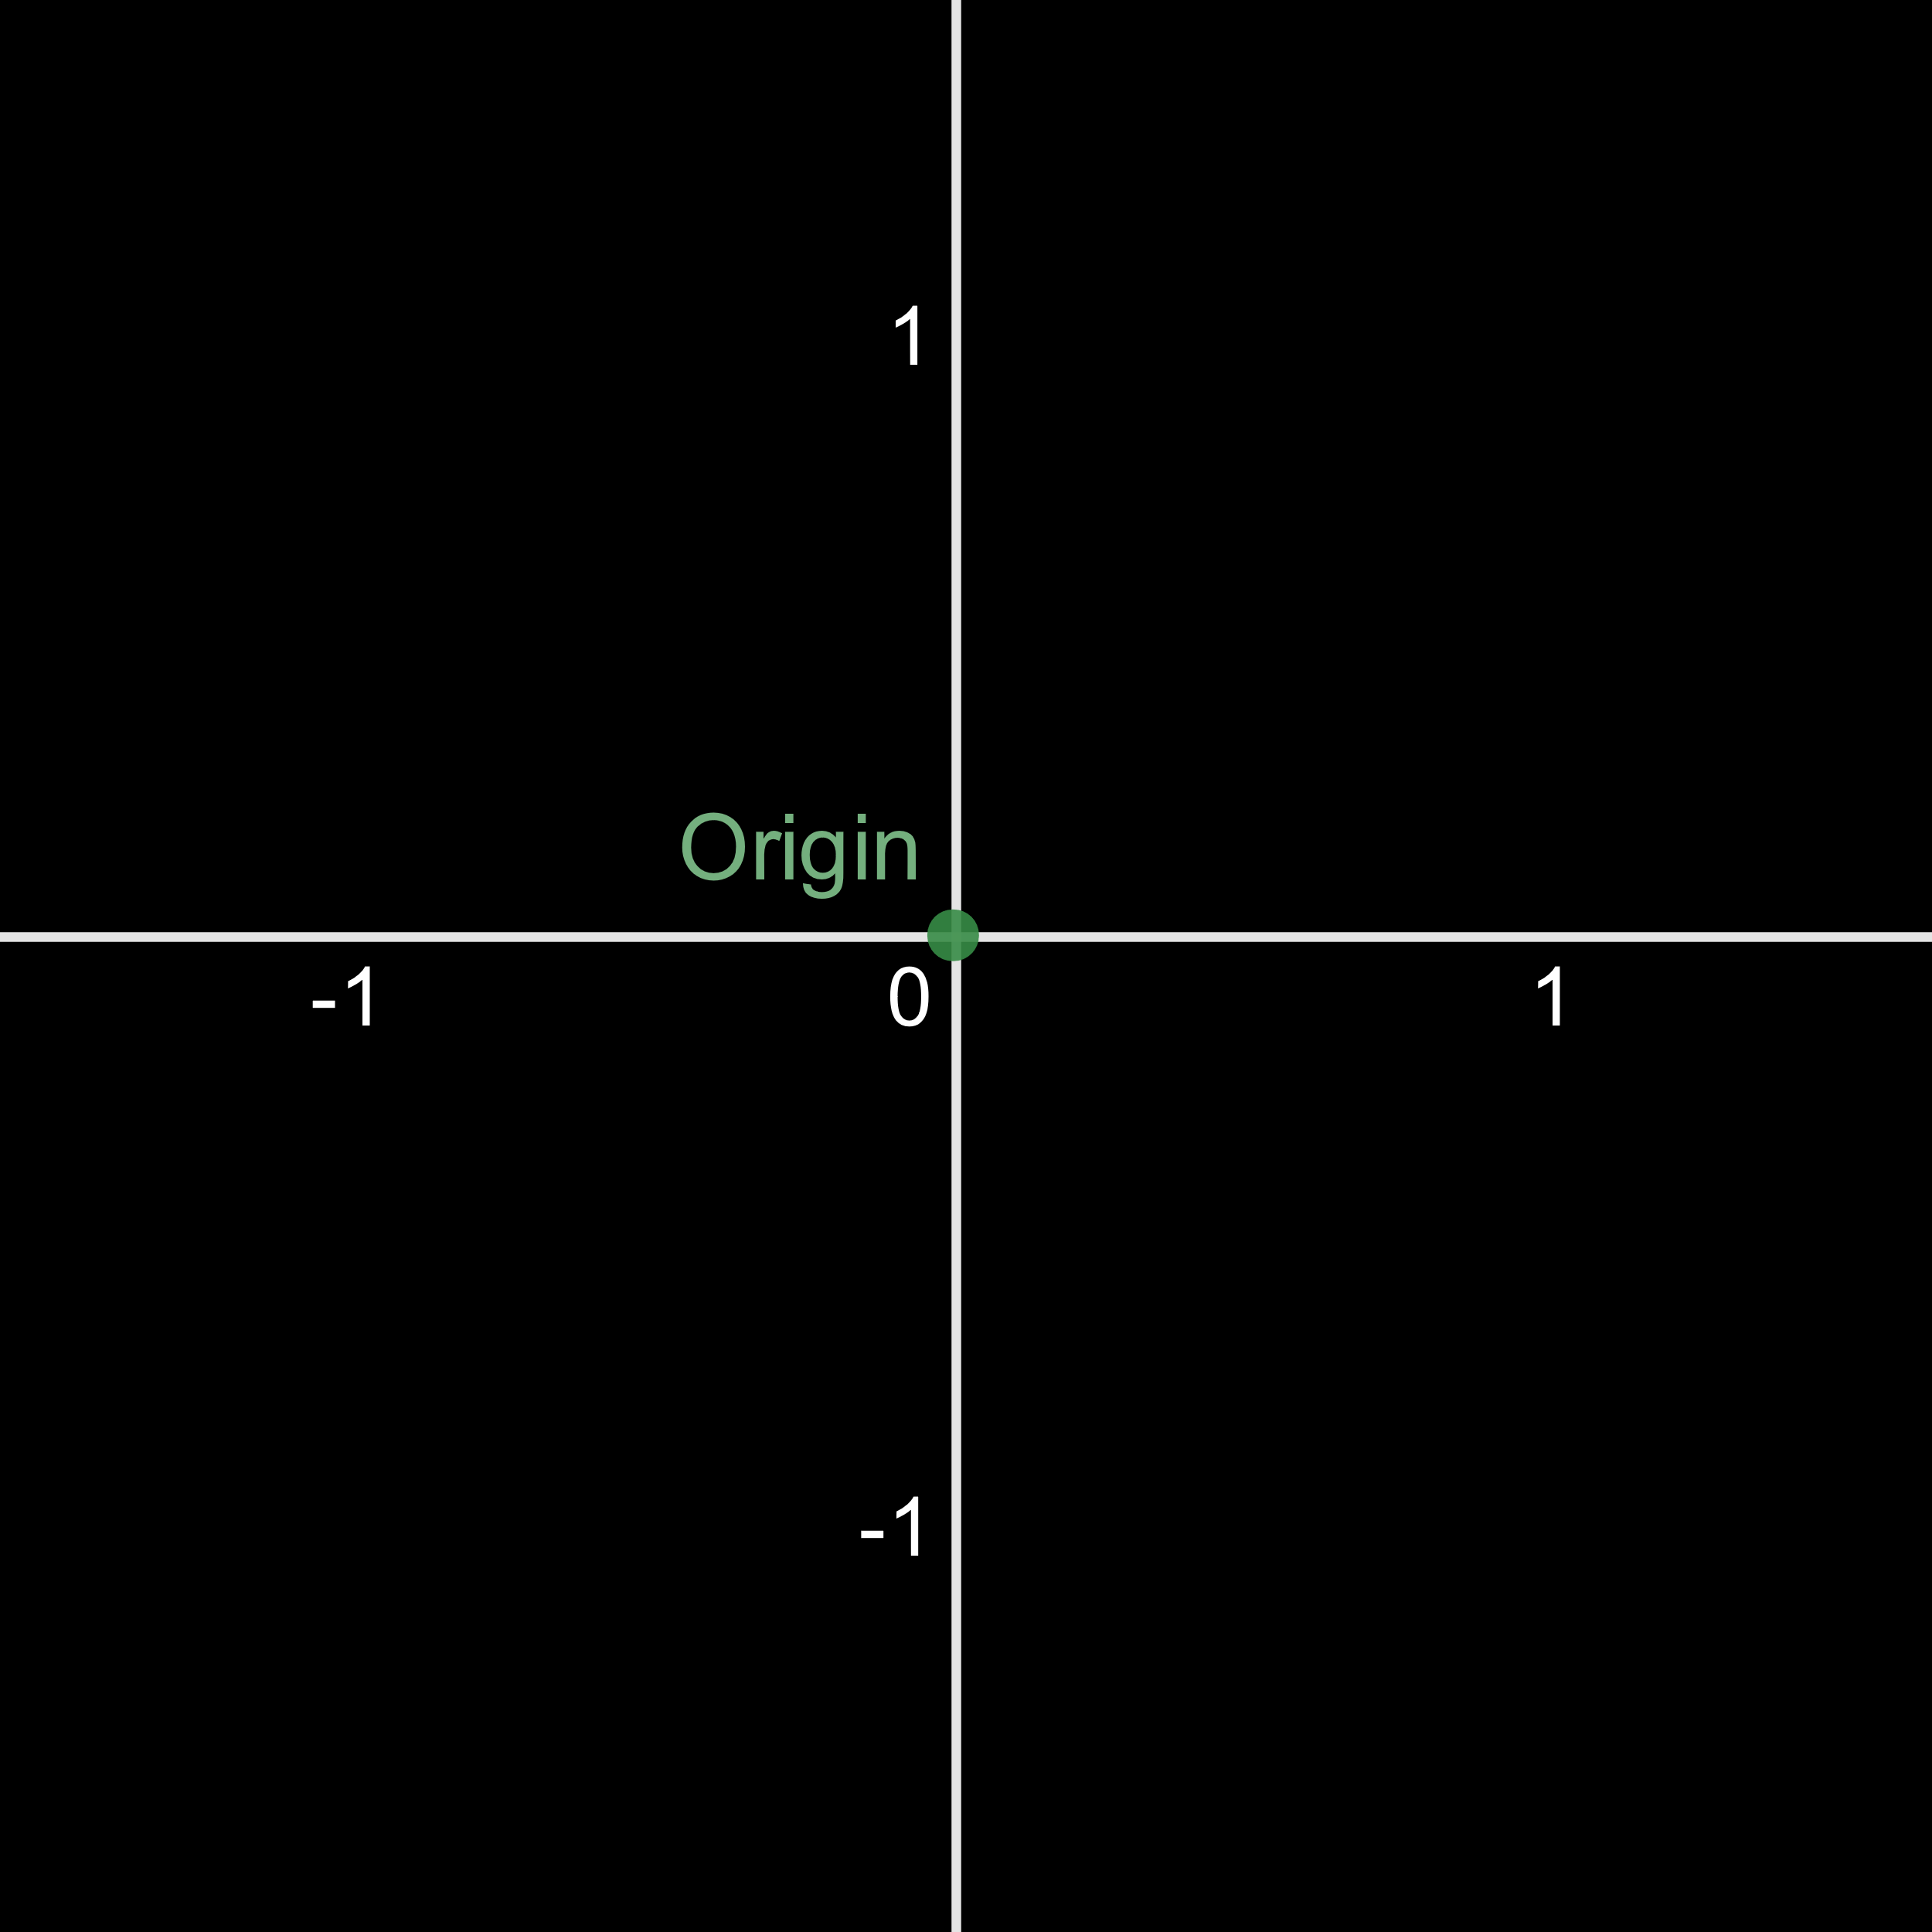Rectangular Axes System – axis with an angle of $90°$ between them.

Oblique Axes System – axis with an angle that is not $90°$ between them.

$$P$$

$$P'$$

## Dividing Co-ordinates

Co-ordinates Internally Divided:

$$A\left(x_{1}, y_{1}\right)$$

$$B\left(x_{2}, y_{2}\right)$$

$$P\left(x, y\right)$$

$$x=\frac{x_{1}m_{2}+x_{2}m_{1}}{m_{1}+m_{2}}$$

$$y=\frac{y_{1}m_{2}+y_{2}m_{1}}{m_{1}+m_{2}}$$

Co-ordinates Externally Divided:

$$A\left(x_{1}, y_{1}\right)$$

$$B\left(x_{2}, y_{2}\right)$$

$$P\left(x, y\right)$$

$$x=\frac{x_{1}m_{2}-x_{2}m_{1}}{m_{1}-m_{2}}$$

$$y=\frac{y_{1}m_{2}-y_{2}m_{1}}{m_{1}-m_{2}}$$

## Finding Determinant

$$\begin{matrix} & \begin{matrix}1 & 2 & 3\end{matrix} \\ \begin{matrix}1 \\ 2 \\ 3\end{matrix} & \left[\begin{matrix}x_{1} & y_{1} & 1 \\ x_{2} & y_{2} & 1 \\ x_{3} & y_{3} & 1\end{matrix}\right]\end{matrix}$$

We consider the columns with 1s.

Area of a triangle $=\frac{1}{2}\left|\begin{matrix}x_{1} & y_{1} & 1 \\ x_{2} & y_{2} & 1 \\ x_{3} & y_{3} & 1\end{matrix}\right|$

$=\frac{1}{2}\left|x_{1}y_{2}+x_{2}y_{3}+x_{3}y_{1}-x_{3}y_{2}-x_{2}y_{1}-x_{1}y_{3}\right|$

If three points are collinear, area $= 0$.